LAB 10
Dewmini D M I
IT24101341
01)
i. State the null and alternative hypotheses for the test.
Null Hypothesis – The probability of choosing each type (A,B,C,D) is equal where (p = 0.25 for each)
Alternative Hypothesis – The probabilities of choosing the snack types are not all equal.
ii. Perform a suitable chi-squared test to test the null hypothesis
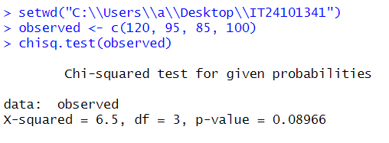


iii. Give your conclusions based on the results.
With a significance level of 0.05, the p-value (0.08966) is greater than 0.05. We fail to reject the null hypothesis. This means there’s not enough evidence to say customers prefer some snack types over others. The vending machine owner’s claim holds.

